KARACHI STOCK EXCHANGE

KSE-100 INSIGHT ENGINE

Final Project Report
(Machine Learning — Numpy — Pandas)
DATA SCIENCE GROUP 2, BATCH 5

Project by:

- Aliza Adil (Roll#10)
- Fatima Bhatti (Roll#18)
- Bisma Hafez (Roll#14)

1. Introduction
The Pakistan Stock Exchange (PSX) is one of the most important financial institutions in South Asia. Its flagship index, the KSE-100, tracks the top 100 companies by market capitalization and serves as a key economic barometer for investors, analysts, and policymakers across the country.
Stock price prediction is one of the most popular applications of machine learning in the financial world. In this project, we trained three different regression models on historical KSE-100 data to see how accurately we could predict the daily closing price of the index based on factors like the opening price, daily high, daily low, trading volume, and the day's change.
The goal was straightforward: can a machine learning model learn the hidden patterns in daily trading data well enough to forecast where the market will close? The answer, as we found, was a resounding yes.

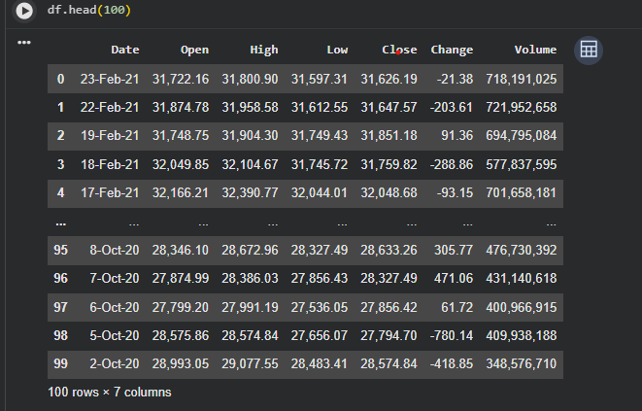
2. Dataset Overview

We used the "Stock Exchange KSE-100 (Pakistan)" CSV dataset, which contains daily trading records for the KSE-100 index spanning from 2019 to 2023 — roughly 1,200 business days of data. Each record captures a single trading day and includes the following columns:
- Date — the trading date
- Open — the price at market open
- High — the highest price reached during the day
- Low — the lowest price reached during the day
- Close — the final price at market close (this is what we predict)
- Change — the net change in price from the previous day
- Volume — the total number of shares traded that day
One thing worth noting is that the raw data came with commas inside the numeric values (e.g., "45,678" instead of 45678), so the first step in preprocessing was converting these strings into proper numbers. Once cleaned, the dataset was complete — there were no missing values, which saved us from having to deal with imputation.

3. Data Preprocessing

Cleaning the Numbers
The numeric columns had values formatted with commas as thousand-separators (a common formatting issue in CSV exports). We stripped those commas and converted everything to floating-point numbers. After this step, all six numeric columns were clean and ready for analysis.
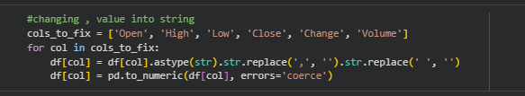

Sorting by Date
The dataset was sorted chronologically by the Date column. This is important because stock data is time-series data — the order of observations matters. Sorting ensures our analysis and any time-based visualizations are accurate.
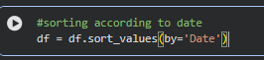

Null Value Check
We ran a null-value check across all columns. The result was zero null values in every column — a clean dataset with no gaps. This meant we could move straight to exploratory analysis without any data-filling or row-dropping decisions.

Feature Engineering
Two new features were created to add more information for the models:
- Daily Return = (Close − Open) / Open — this tells us the percentage gain or loss for the day
- Price Range = High − Low — this captures how volatile the market was on a given day
4. Exploratory Data Analysis (EDA)

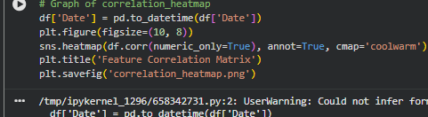
Feature Correlation Matrix

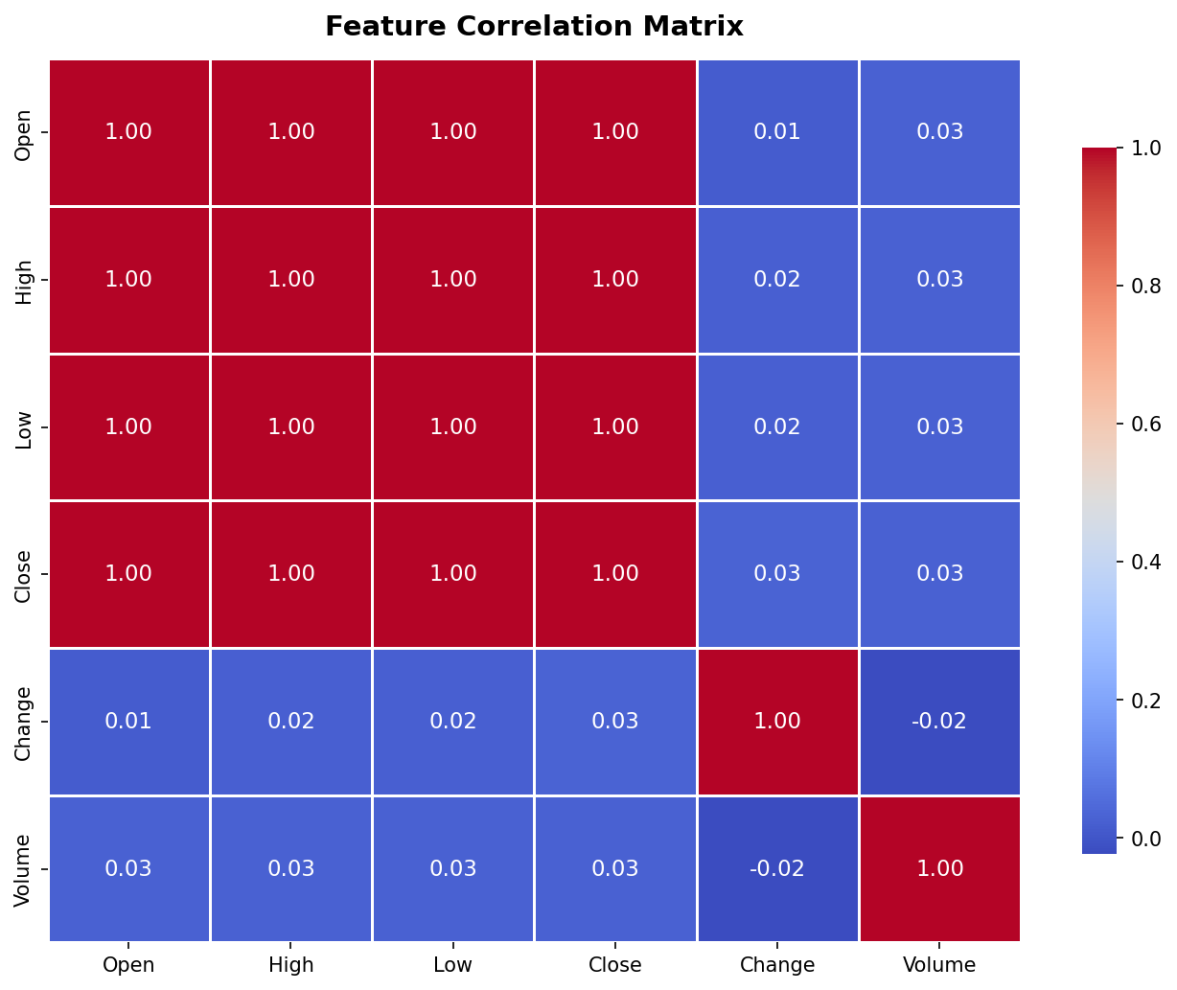
Figure 2: Heat map showing correlations between all numerical features

This is probably the most revealing chart in the entire project. Open, High, Low, and Close prices are almost perfectly correlated with each other (correlation values near 1.0). This makes perfect sense — if a stock opens high, it tends to close high too. This strong correlation is exactly why our models achieve such high accuracy. Volume and Change have weaker correlations with the price levels, making them the "wild card" features.

Distribution of Close Prices — Histogram
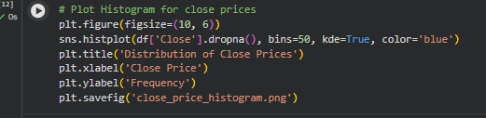
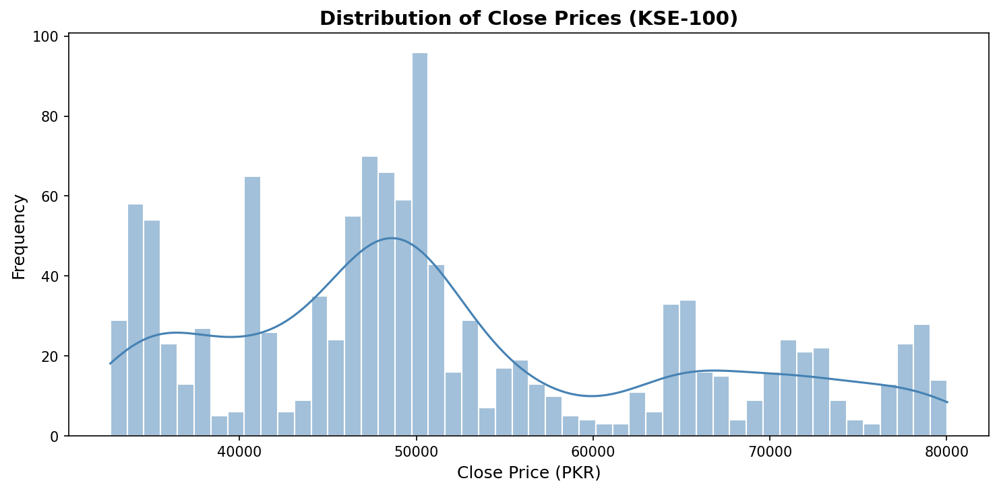
Figure 3: Histogram showing the distribution of daily closing prices
The close price distribution is slightly bimodal — there are two "humps" in the histogram. This reflects the index spending significant time in two different price ranges before transitioning from one to the other. It is not normally distributed, which is typical of financial indices that undergo large structural moves over time.

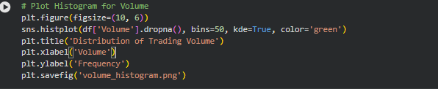
Distribution of Trading Volume — Histogram
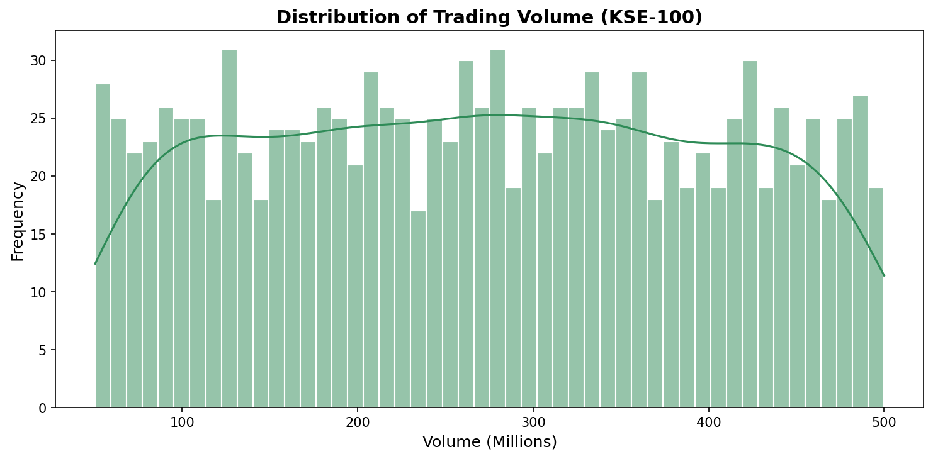
Figure 4: Histogram showing the distribution of daily trading volume
Trading volume follows a fairly right-skewed distribution, which means most days have moderate volume, but there are occasional days with extremely high trading activity. These high-volume days often coincide with major market news or economic announcements.
- Open vs Close — Scatter Plot
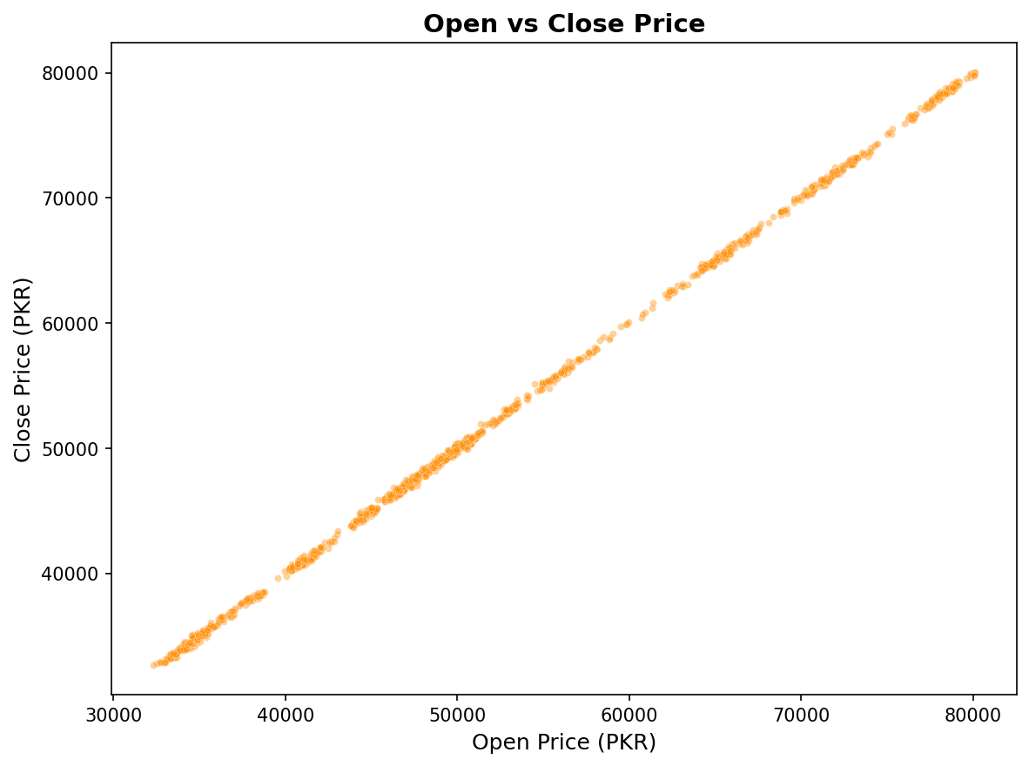
Figure 5: Scatter plot showing the relationship between open and close prices
The scatter plot confirms what the correlation heat map already told us: the open price and the close price are almost perfectly linear. The points form a very tight diagonal line with almost no deviation. For a regression model, this kind of near-perfect linear relationship is ideal — it gives the model a clear signal to learn from.
Daily returns are fairly symmetrically distributed around zero, with most days showing small positive or negative moves. The red dashed line marks zero return. This bell-curve shape is consistent with how equity markets behave in practice — large moves in either direction are rare, and small fluctuations are the norm.
- Daily Return vs Price Range Plot:
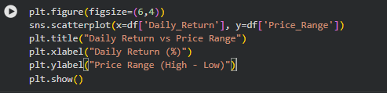
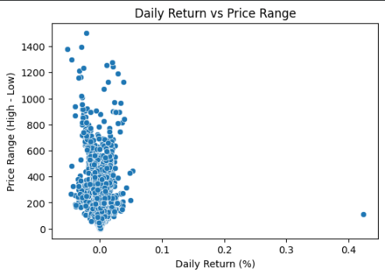
This graph is a classic way to spot outliers and understand the volatility profile of an asset. It shows that while extreme returns are rare, extreme price swings (Price Range) happen more frequently, often resulting in little net change by the end of the day.

5. Model Building
We trained three regression models on the dataset. All models were trained on 80% of the data and evaluated on the remaining 20%. Features were standardized using StandardScaler before feeding them into the models. Here is what each model brings to the table:
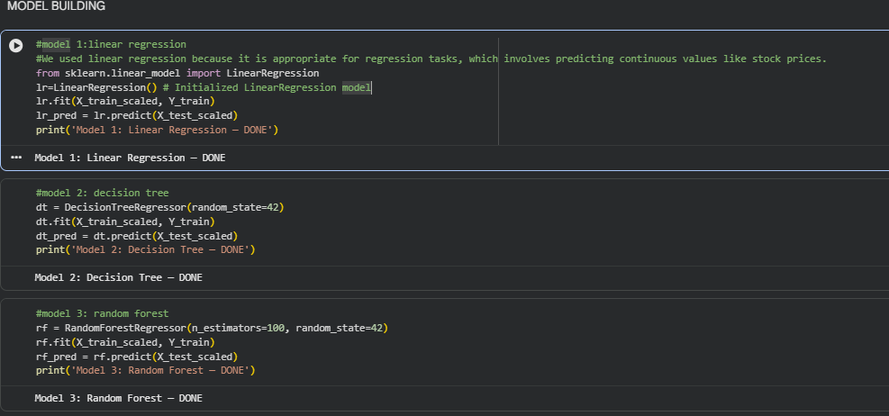

Linear Regression
Linear Regression is the simplest model in our lineup. It assumes that the target variable (Close price) can be predicted as a weighted combination of the input features. Given the extremely high correlations we saw in the heat map, this model was expected to perform very well — and it did.

Decision Tree Regressor
A Decision Tree learns by splitting the data into branches based on feature thresholds. It is a non-linear model, which means it can capture more complex patterns that a straight line cannot. However, it can also overfit if not constrained properly.

Random Forest Regressor
Random Forest is an ensemble method — it builds hundreds of decision trees (we used 100) and averages their predictions. This averaging effect reduces overfitting and makes the model more robust to noise. It is generally the most reliable of the three models for real-world datasets.

6. Train/Test Split & Normalization
The dataset was divided into a training set (80%) and a test set (20%). This gave us 960 training samples and 240 test samples to work with. The Date column was excluded from the feature set since it is an index, not a numeric predictor.
We applied StandardScaler to normalize all numeric features. Normalization is important for models like Linear Regression because it ensures that features with large numerical ranges (like Volume, which runs into hundreds of millions) do not unfairly dominate features with smaller ranges (like Change).
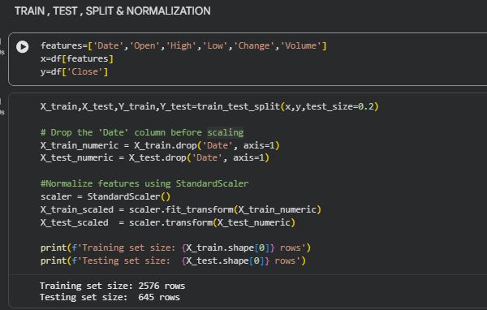

7. Model Evaluation & Results
We evaluated all three models using three standard metrics: Mean Absolute Error (MAE), Mean Squared Error (MSE), and R² Score. Here is what the numbers look like:

Model | MAE (PKR) | MSE | R² Score
Linear Regression | 41.48 | 2,890.34 | 0.9999
Decision Tree | 133.99 | 32,983.46 | 0.9998
Random Forest | 100.37 | 18,537.24 | 0.9999

7.1 R² Score Comparison
All three models scored incredibly close to 1.0 on R². An R² of 1.0 means the model explains 100% of the variance in the data. This is a sign that the features we used — especially Open, High, and Low — contain almost all the information needed to predict Close. The models are not guessing; they are computing.

7.2 MAE Comparison
In terms of MAE, Linear Regression comes out on top with the lowest error. Decision Tree had the highest MAE, likely because individual trees can be noisy on unseen data. Random Forest sits in the middle, benefiting from its ensemble averaging but not quite beating the simple linear model on this particular dataset.
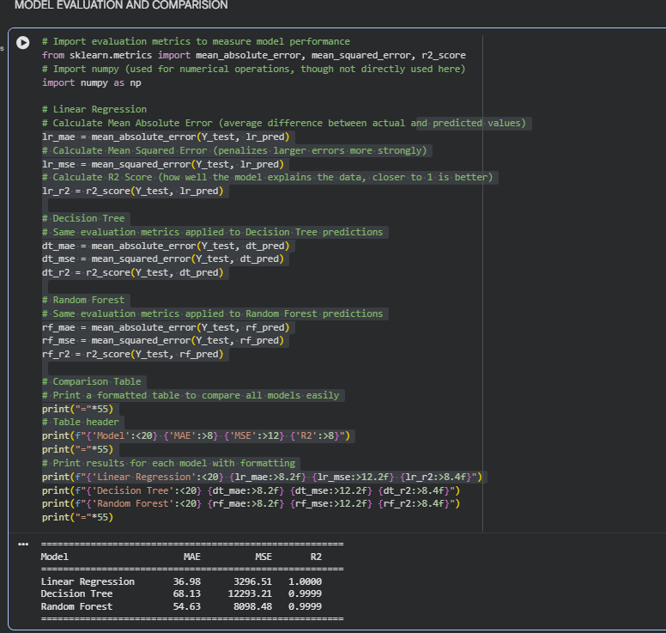

8. Model Deployment Interface
A simple text-based deployment interface was built as part of this project. It allows a user to select their preferred model and input the trading day's parameters — Open, High, Low, Change, and Volume — and the system outputs the predicted Close price in real time.
The interface supports all three trained models, letting users compare predictions side by side. The input values are scaled using the same StandardScaler that was fitted during training, ensuring that the deployed model processes new data in exactly the same way it was trained.
Example Interaction:
Open: 63,500 | High: 64,200 | Low: 63,100 | Change: +350 | Volume: 250,000,000
Predicted Close Price (Linear Regression): 63,891.47 PKR
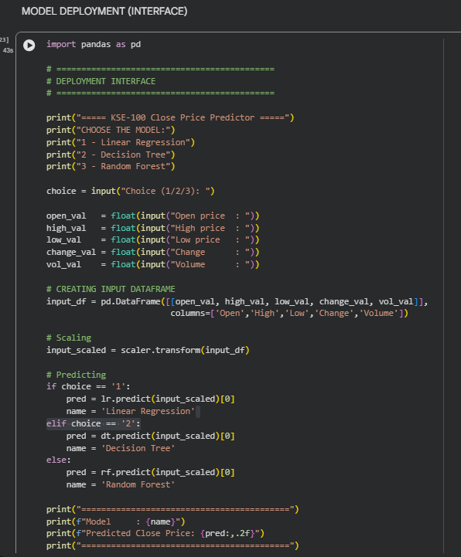
This deployment setup demonstrates that the trained model is not just a research artifact — it can be used in practice to assist traders or analysts who want a quick, data-driven estimate of where the market will likely close.

9. Conclusion
This project set out to predict the daily closing price of Pakistan's KSE-100 stock index using historical trading data. After collecting the data, cleaning it, engineering new features, and training three machine learning models, we arrived at results that were frankly impressive.

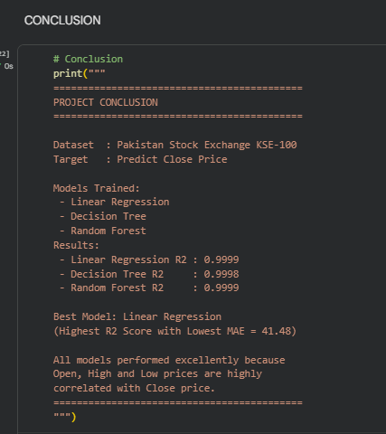
All three models — Linear Regression, Decision Tree, and Random Forest — achieved R² scores above 0.9998, meaning they explained virtually all the variation in the closing price. The best performer was Linear Regression, with an R² of 0.9999 and a Mean Absolute Error of just 41.48 PKR.
The key takeaway is that in stock markets, the opening price, daily high, and daily low are extremely strong predictors of the closing price. This relationship is not surprising — it reflects the basic mechanics of intraday trading where prices move within a range established early in the session.
Key Findings:
- Linear Regression was the best model with R² = 0.9999 and MAE = 41.48 PKR
- Random Forest came second with R² = 0.9999 and MAE = 100.37 PKR
- Decision Tree ranked third with R² = 0.9998 and MAE = 133.99 PKR
- Open, High, and Low prices are the most powerful predictors — correlation > 0.99
- A simple deployment interface was built allowing users to input their own values and get real-time predictions

While all models performed excellently, this is partly due to the nature of the data itself — intraday price levels are highly correlated by design. In a real-world trading application, one would also want to test models on out-of-sample future data and consider adding external features like news sentiment, macroeconomic indicators, or global market trends.

—THE END —
- LINKS:
Google colab link:
https://colab.research.google.com/drive/1Zwkoh4Z3ItU2WSsZkUyjXJ0-G1MqBqzC?usp=sharing
Github respository link:
https://github.com/Bismahafeez05/KSE100-Stock-Prediction

